2020

Management Plan

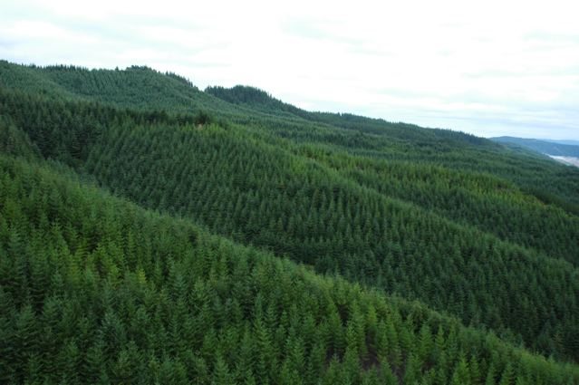

June 2020

1. Introduction 4
2. The Forest Estate 4
2.1 Golden Downs Forest 6
2.2 Rai Forest 6
2.3 Marlborough Freehold Forest 6
2.4 Nelson Freehold Forests 7
2.5 Joint Venture Forests 7
3.0 Resource Description 7
4. Management Objectives 8
4.1 Safety: 9
4.2 Environment: 9
4.2.1 Natural forest conversion and restoration 9
4.3 Quality: 11
4.4 Finance: 11
5. Species Selection 11
6. Silvicultural Management 11
6.1 Site Preparation 11
6.2 Planting and Silviculture: 11
7. Monitoring Forest Growth 12
7.1 Inventory 12
7.2 Permanent Sample Plots and Trials 12
7.3 Nutrition Monitoring 12
7.4 Forest Health Monitoring 13
8. Annual Harvest 13
9. Harvesting Techniques 13
10. Land Use 13
11. Socio-Economic Conditions 14
12. Environmental Monitoring 15
13. Threatened Species 15
14. Further Reading 15

Photo credit: Dave Hill. Golden Downs Forest

1. Introduction

Australian forest and timber processing company OneFortyOne Plantations (OFO) acquired Nelson Management Limited in 2018. OneFortyOne was formed in 2012 following the acquisition of a 105-year lease of 80,000 hectares of plantation assets from the South Australian Government. Since that time, OFO has become an established industry player within Australia, with a strong track record of industry and community partnerships.

OFO uses a local management team, Nelson Management Ltd (NML) - trading as OneFortyOne - to effect successful operations on the ground in the Nelson, Tasman and Marlborough regions of New Zealand. Our skilled and knowledgeable people are committed to the sustainable management of the high-quality forest plantations.

Lees Seymour, Executive General Manager New Zealand of OneFortyOne NZ, Linda Sewell CEO of OneFortyOne and Chair of the Board for OneFortyOne, John Gilleland
OneFortyOne has a vision to be the most nimble, curious, profitable and best regarded wood fibre company. We drive to redefine the value of fibre, exploring new ground for the industry and extracting value from every cell of fibre, from every tree planted. We strive to be 'the creative fibre group' and a leader in the forestry industry.

2. The Forest Estate

As at 1 February 2020, OneFortyOne (OFO) manages 79,927 hectares of which 67,008 hectares is stocked. The most recent addition to the forest estate was the acquisition of Manuka Island in Wairau Valley, comprising 2,400 hectares of land, with 1,900 hectares stocked. The forest area consists of three ex-Crown Forest License areas (Golden Downs West, Golden Downs East and Rai) in Iwi ownership, freehold forests and four joint venture forests.

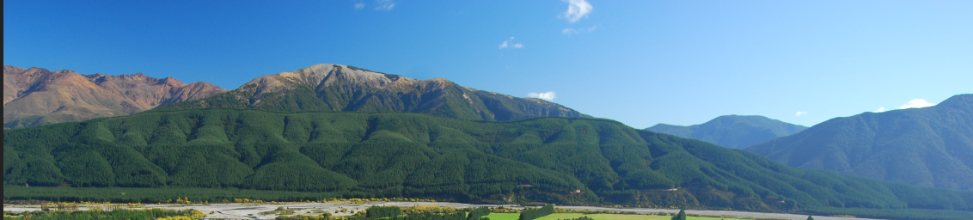
Manuka Island forest

As a result of Ngāti Kōata, Ngāti Rārua, Ngāti Tama ki Te Tau Ihu, and Te Ātiawa o Te Waka-a-Māui Claims Settlement Act 2014, and the Ngāti Toa Rangatira Claims Settlement Act 2014, the original four Crown Forest Land parcels (Wairau, Rai, Golden Downs West and Golden Downs East Crown Forestry Licenses) have been transferred to Iwi ownership as part of the Settlement redress to Iwi.
• Wairau Crown Forest Land was included in the Settlement redress to Ngāti Rārua.
• Golden Downs East Forest Land was included in the Settlement redress to Ngāti Toa Rangatira
• Rai Forest Land was divided roughly in half and one half has been included in the Settlement redress to Te Ātiawa o Te Waka-a-Māui and the other half has been included in the Settlement redress to Ngāti Tama ki Te Tau Ihu
• Golden Downs West Forest Land was divided into four separate parcels and one part included in the Settlement redress to Ngāti Toa Rangatira, one part to Ngāti Tama ki Te Tau Ihu, one part to Te Ātiawa o Te Waka-a-Māui and one part is held jointly between Ngāti Tama ki Te Tau Ihu and Te Ātiawa o Te Waka-a-Māui.

Termination notices were issued to Nelson Forests Limited (NFL) in respect to each of the Crown Forestry Licenses in 2014. The Notices have the effect that OFO has 35 years under the Crown Forest Licence to harvest the remaining standing plantation trees and any land cleared (harvested) of forestry trees is to be “returned” or handed back to Iwi.

NML welcomed the Settlement and the opportunity to partner with the new Iwi Land Owners. There is acknowledgement that the need for a long-term view in forestry (because of the time for the trees to grow) aligns well with Iwi. New relationships have been formed. The Crown Forest Licenses are being replaced with separate Forestry Rights covering the Land owned by Ngāti Toa, Ngāti Tama, Te Ātiawa and the Golden Downs West land held in joint venture between Ngāti Tama and Te Ātiawa. The new Forestry rights each have a 20-year initial fixed term, followed by an automatic annual extension until a 35-year Termination notice is issued.
Ngāti Rārua, the beneficial owner of the land under the Wairau Crown Forest License area, decided to sell their interest in the Wairau forest land to Nelson Forests Limited in 2015.

The following map shows the land ownership across the OneFortyOne Estate as at 1 February 2020.

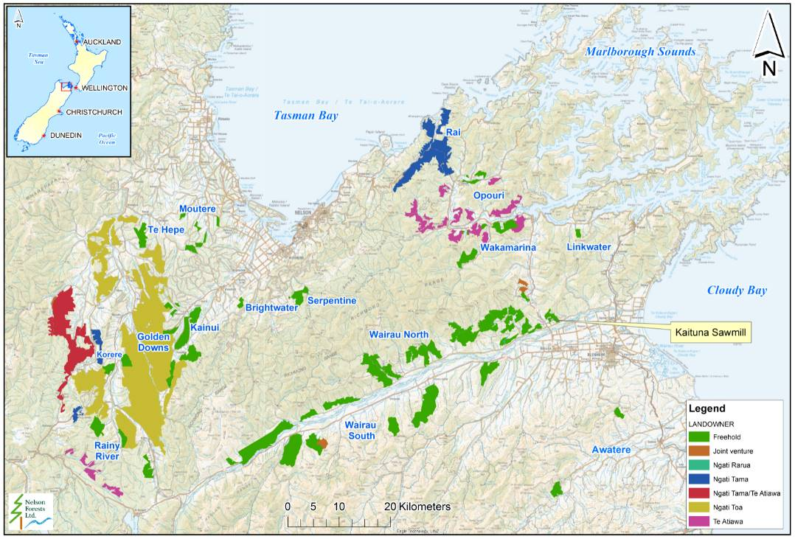
OneFortyOne estate: location and underlying land ownership

2.1 Golden Downs Forest
Golden Downs is the largest forest unit in the Nelson/ Marlborough region, with a total area of 41,702 ha. It is located approximately 60 km southwest of Nelson City. Golden Downs has a range of geographical features from very steep broken hill country bordering the Kahurangi National Park to easy rolling hill country and river flats. The State Highway from Nelson to the West Coast (SH6) bisects the forest. A number of rivers flow through Golden Downs Forest including the Baton, Motueka, Motupiko, Wangapeka, Tadmor, Dart and Stanley Brook. Most of the forest is situated on Moutere gravel soils. Smaller outlying blocks to the west are on soils classed as separation point granites, which are regarded as highly erodible. Land use adjacent to the forest is predominantly farming, forestry and conservation.

2.2 Rai Forest
Rai Forest lies on both sides of the Nelson-Blenheim highway (SH6) in several blocks and extends from the top of the Whangamoa saddle to the township of Havelock, covering a total area of 11,356 ha. Most of the valley systems leading off the highway and running out to the eastern coastline of Tasman Bay contain parts of the forest. The Whangamoa, Rai, Wakamarina and Pelorus Rivers run through parts of the forest. Soils are predominantly clay soils on steep topography. Mineral belts (Serpentine) run through small parts of the forest. Land use adjacent to the forest is predominantly dairy and drystock farming, lifestyle farming, forestry and conservation.

2.3 Marlborough Freehold Forest
The Marlborough freehold forests include Wairau Northbank and Manuka Island, which are situated on the eastern side of the Mt Richmond Forest Park. The Wairau Northbank forest is made up of a series of blocks, which extend along the north bank of the Wairau River to the south-west of the SH63 Bridge (Washbridge). Topography consists of rolling to steep hill country. Soils are predominantly Onamalutu steepland soils. Land use adjacent to the forest is predominantly farming, viticulture, lifestyle farming, forestry and conservation.
The remaining Marlborough Freehold forests include; Wairau South Forest, Linkwater, Wakamarina, Kaituna Sawmill forest, the Opouri Valley and the Awatere Valley. Topography consists of rolling to steep hill country. Land use adjacent to the forest is predominantly farming, lifestyle farming, viticulture, forestry and conservation. The total area of these forests is 18,792 ha.

2.4 Nelson Freehold Forests
The majority of the Nelson freehold forests lie on the foothills of the Waimea basin (Serpentine, Kainui, Moutere, Te Hepe and Brightwater). Smaller freehold forests are located adjacent to Golden Downs Forest (Korere). The total area of these forests is 7,457 ha. Topography consists of rolling to steep hill country. Land use adjacent to the forest is predominantly farming, lifestyle farming, viticulture, forestry and conservation.

2.5 Joint Venture Forests
A number of relatively small joint venture forests are established in the Nelson and Marlborough region, covering an area of 646 ha. These are generally set up as Forestry Right agreements.

2.6 Total Forest Areas by Region
Region | Area
Golden Downs / Nelson | 49,241 ha
Rai Forests | 11,361 ha
Marlborough / Wairau | 19,325 ha
Total | 79,927 ha

3.0 Resource Description

Land & Forest Area Description
Planted Area | Current ha
1. Pinus radiata | 55,072
2. Douglas fir | 4,059
3. Minor species | 987
Total Planted Area | 60,118
Available for Planting | 2,916
Potentially plantable (unstocked gaps/windthrow) | 3,974
Total Productive Land | 67,008
Non-Productive Land | Current ha
Covenants / Significant Natural Areas | 2,604
Bush / indigenous forests / wetlands | 5,928
Unplanted riparians / transmission lines / fire breaks | 962
Retired from production | 1,525
Roads / landings | 1,440
Unplanted other | 460
Total Non-Productive Land | 12,919
Total Land | 79,927
Table 1: Land and Forest area description as at 1 February 2020

4. Management Objectives
The long-term environmental goals (measurable where possible) that OFO sets itself, arise from the environmental policy and the effects evaluation.

Environmental Management Policy
Environmental Policy | Maintain OFO’s environmental stewardship and performance by demonstrating the promotion and care of a healthy functioning environment.

Environmental Principle | To identify, evaluate and manage the significant environmental effects of plantation forestry on the environment.

Compliance Principle | To manage and control activities to comply with environmental legislation and regulations, and the following voluntary codes:  - National Environmental Standard – Plantation Forestry  - Resource Management Plans from the Nelson, Marlborough and Tasman Councils  - NZ Forest Accord  - Principles for Commercial Plantation Forestry Management in NZ  - NZS 8409:2004 Management of Agrichemicals  - NZFOA Environmental Code of Practice for Plantation Forestry  - NZ Climate Change Accord  - Environmental Certification Principles and Criteria  - New Zealand Wilding Conifer Management Strategy

Environmental Management Principle | To train and empower staff to manage operations to ensure that desirable environmental outcomes are planned and achieved, and that environmental effects are accepted and sustainable.

Cautionary Principle | To take a cautious approach in operations where the adverse effects of the operation cannot be confidently predicted.

Continuous Improvement Principle | To continuously improve environmental management through regular audits and reviews of the EMS, through environmental research and monitoring of operations.

Future Well-being Principle | To work towards the sustainable management of the natural and physical resources we own or manage, to provide for the well-being of future generations.

Community Principle | To provide for managed recreational & community activities within and adjacent to our forests.  To consult with affected persons and demonstrate openness in questions concerning all significant environmental aspects of our activities.

Tangata and Mana Whenua Principle | To develop a relationship with tangata and mana whenua that is equitable and has clarity and transparency in all processes.

The overall management of the OFO forest estate has the overall objective of achieving excellence across four key areas:
- Safety
- Environment
- Quality
- Finance

4.1 Safety
The health, safety and wellbeing of all workers and visitors to OneFortyOne is the core of our culture and values as a business. We constantly strive to improve our management of health and safety relationships and processes as a Person in Charge of a Business or Undertaking (PCBU) to deliver a safe work environment for everyone. OFO undertakes industry benchmarking, external audits and reviews and also participates in health and safety forums to challenge and inform us about how to improve. We focus on leadership, worker engagement and risk management, to ensure that wellbeing, health and safety is embedded in the way we do business and that we deliver positive outcomes.

4.2 Environment
OFO maintains an Environmental Management System that locks in current performance and provides a base for continuous improvement toward industry best practice and the pursuit of our Vision. As stated in the Environmental Management Policy, OFO will manage and control activities to comply with environmental legislation and regulations including the National Environmental Standards for Plantation Forestry (NES-PF), environmental certification and the following voluntary codes:
- NZ Forest Accord
- Principles for Commercial Plantation Forestry Management in NZ
- NZ Agrichemical Users Code of Practice
- NZ Wilding Conifer Management Strategy

We also aim to be a responsible member of the local community, and one that listens to its stakeholders.

4.2.1 Natural forest conversion and restoration
The OFO Forest Management Unit (FMU) contains a range of non-plantation areas that are set aside and maintained as natural indigenous forest areas for maintaining indigenous biodiversity. With the inclusion of Manuka Island forest, 10,391 ha or 13.4 % of the working forest area within the FMU is designated as set-asides. A full breakdown of the components of the set aside areas is provided below and in the annual Monitoring Plan.
The management objective for these areas is to promote the protection, restoration and conservation of indigenous forests, and not increase pressures on indigenous forests. As part of the overall management objective for the forest a minimum of 10% reserve set-asides or equivalent by Ecological District shall be managed and /or restored to natural vegetation over time.

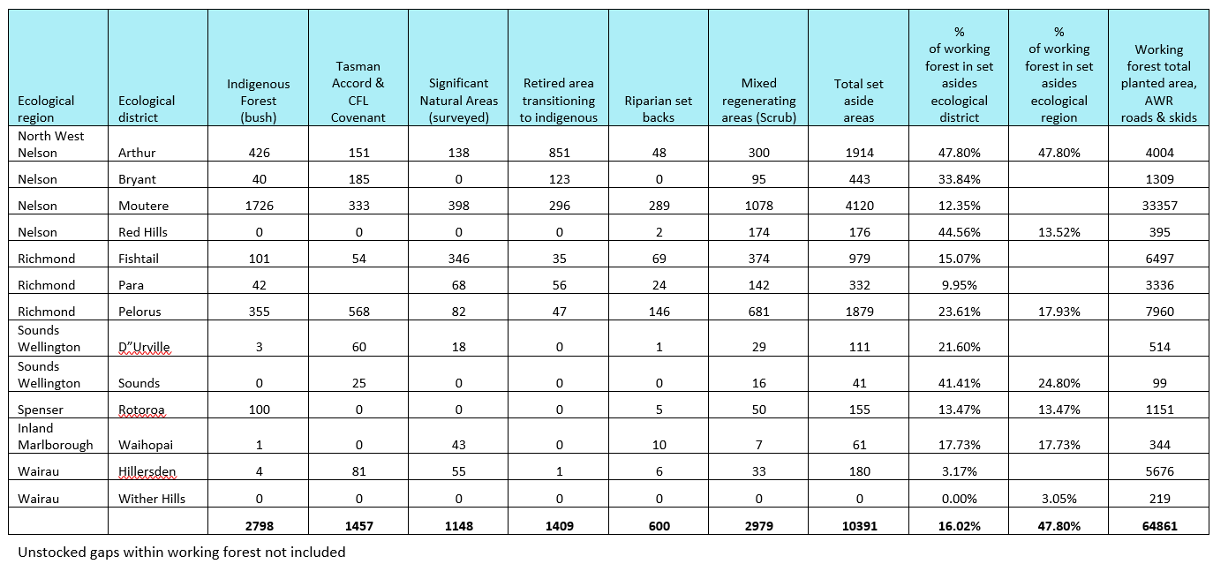
Set-aside areas within the OneFortyOne Estate
In the Hillersden and Wither Hills Ecological Districts (EDs), the total set-aside areas currently only represent 3.05 % of the working forest. The forests were established on impoverished agricultural land that had been denuded of any natural vegetation through decades of matchstick farming. As we harvest the Wairau Southbank forests, we will explore opportunities to provide additional protection to existing set-asides and establishing new set asides, particularly near waterways. OFO has considered contributing equivalent ecological effort recognising that achieving 10 % set-asides in the Hillersden and Wither Hills EDs is unlikely. OFO, in consultation with Department of Conservation, has identified wilding conifers as the priority ecological issue for forestry in the Nelson Marlborough area. As a result, OFO has partnered with the Mount Richmond Forest Park Wilding Conifer Management Unit stakeholders group and has committed to an annual contribution for 5 years of $50,000 in cash and a further $50,000 as in kind wilding control work to count as equivalent ecological effort under the National Standard for Certification of Plantation Forest Management in NZ.

4.3 Quality:
OFO focuses on effective planning to achieve process reliability across the forest growing and harvesting cycle. Establishment and Silviculture practices are managed through best practice documents in a Forestry Operations manual. Process reliability in log manufacture incorporates calibration of processing equipment, operator training and a systematic sample (quality assurance) of product from all OFO harvest crews on a weekly basis. Information is distributed internally on weekly basis and shared with contractors and customers on monthly basis.

4.4 Finance:
The pursuit of financial excellence will be dependent on obtaining and maintaining an internationally competitive cost position that allows the capture of the value naturally inherent in our Nelson forests, and which will be further enhanced by a dedication to customer needs. As a small organisation we have the ability to focus on a small number of critical customers who we aim to provide with a consistent product and service.

5. Species Selection

Establishment and silviculture practices are adopted with the objective of maximising the value of the forest resource while mitigating and/ or managing any risk factors.
Radiata pine (Pinus radiata) is the predominant species. Radiata Pine has been selected as the preferred species following extensive trials and numerous regime analyses’ over time. Trials also exist within the forest evaluating other potential commercial species. The type of tree grown in the Nelson region has good density and branching habit, which assists in meeting product consistency and recovery.

6. Silviculture Management

OFOs objective of tree crop management is to produce high-quality structural logs with high wood stiffness and small branching. The estate is managed on a standard regime for Radiata Pine being the species most adapted to the sites that the estate occupies.

6.1 Site Preparation
On ground-based sites (typically below 26 degrees slope) mechanical land preparation is practised to rake the site and remove woody debris, where required, so that cuttings and seedlings can be planted into soil. Approximately 30 % of the area to be planted each year is treated by this method.
A pre-plant spray is used on all sites to kill weeds and regenerating conifers from the cones of the previous crop, before establishing the radiata cuttings or seedlings. A record of our chemical management is provided each year in our Monitoring report.

6.2 Planting and Silviculture:
The current establishment strategy is to plant all sites into Radiata pine for a structural regime. Approximately 10% of the planting stock are cuttings the remaining stock is a 60/40 mix of control and open pollinated bareroot seedlings. Clonal plants are being trialled but no significant areas are planted in clonal material. The initial stocking for the majority of the sites is 800 seedlings per hectare (sph), with the intention of a non-commercial thin to take place when the trees achieve a target mean top height (MTH) of 14 meters to a final crop stocking of 550 sph. In areas where either the terrain makes thinning to waste too risky or where the risk of windthrow is too high, a plant and leave strategy is used. In this case, an initial stocking of 667 sph is practiced. No Pruning is undertaken.

7. Monitoring Forest Growth

Forest growth is measured primarily from inventory data and through growth modeling. OFO uses the following software packages to assist in modeling forest growth.
- 300 Calculator
- YTGen
- Woodstock

As well as inventory data, a network of trials exists to assist in improving the growth models. Foliage sampling for needle nutrient levels and forest health surveys are also undertaken to assist in monitoring forest growth and performance.

7.1 Inventory
Regular forest inventory sampling monitors forest growth and development over the period of the rotation. Cengea’s Forest Management Module (FMIS) is used as the primary software for the storage of stand records. Inventory monitoring generally includes:
- Pre-assessment as required (age 5-7) – prior to tending operations.
- Quality Control (age 8 - 12) – following tending.
- Tactical (age 17 - 23) – to obtain tree size and estimate of recoverable volume by log grade to assist harvest planning and forecast medium and long term log grades.
- Pre-Harvest (24 - 28) – to obtain estimate of recoverable volume by log grade.

Remapping of forest and cutover is undertaken using both satellite images and aerial surveys. This generally occurs in association with significant forest events such as harvesting or following storm damage.

7.2 Permanent Sample Plots and Trials
Over 100 Permanent Sample Plots (PSP’s) exist within the forest. These plots are measured at regular intervals to monitor growth over the rotation. The results of these plots are used to assist in refining forest growth models. A number of other trials exist in the forest, monitoring key factors e.g. silviculture, establishment practices, and genetics.

7.3 Nutrition Monitoring
An annual nutrient assessment is undertaken each year to monitor the levels of foliage nutrient levels across the estate. Age three trees are targeted as well as any stands that are beginning to show signs of deficiencies.

7.4 Forest Health Monitoring
An annual forest health survey is undertaken to the New Zealand Forest Owners Association (NZFOA) standards to detect any potential new pests and diseases, as well as to monitor changes in existing pest and diseases.

8. Annual Harvest

Forest Modeling is undertaken on a number of different levels to predict the productivity of the forest estate. Forest Modeling seeks to achieve a non-declining wood yield to be determined, as well as predicting the likely grade out-turn to assist in developing potential future markets and meeting customer demands.

Harvest Volumes | 2019 m³
Radiata pine | 855,239
Douglas fir | 252,491
Minor species (Muricata, Eucalyptus, Lawson, miscellaneous | 22,109
Total | 1,129,839

9. Harvesting Techniques

Detailed harvest plans with the method of extraction are developed prior to harvesting. The harvest plans take into account the risks of the operation and other safety considerations, the Resource Management Act and regulations, local government guidelines and regulations, terrain, soil and water management, natural areas, financial considerations, and social/community factors.

At present 14 contract harvest crews operate within the estate. The current split of ground-based verse hauler-based is approximately 35:65.

10. Land Use

Within the estate, there are significant areas that are not production forests. The breakdown of these areas is as detailed in Table 1 on page 10 above and their distribution is shown on the map below.

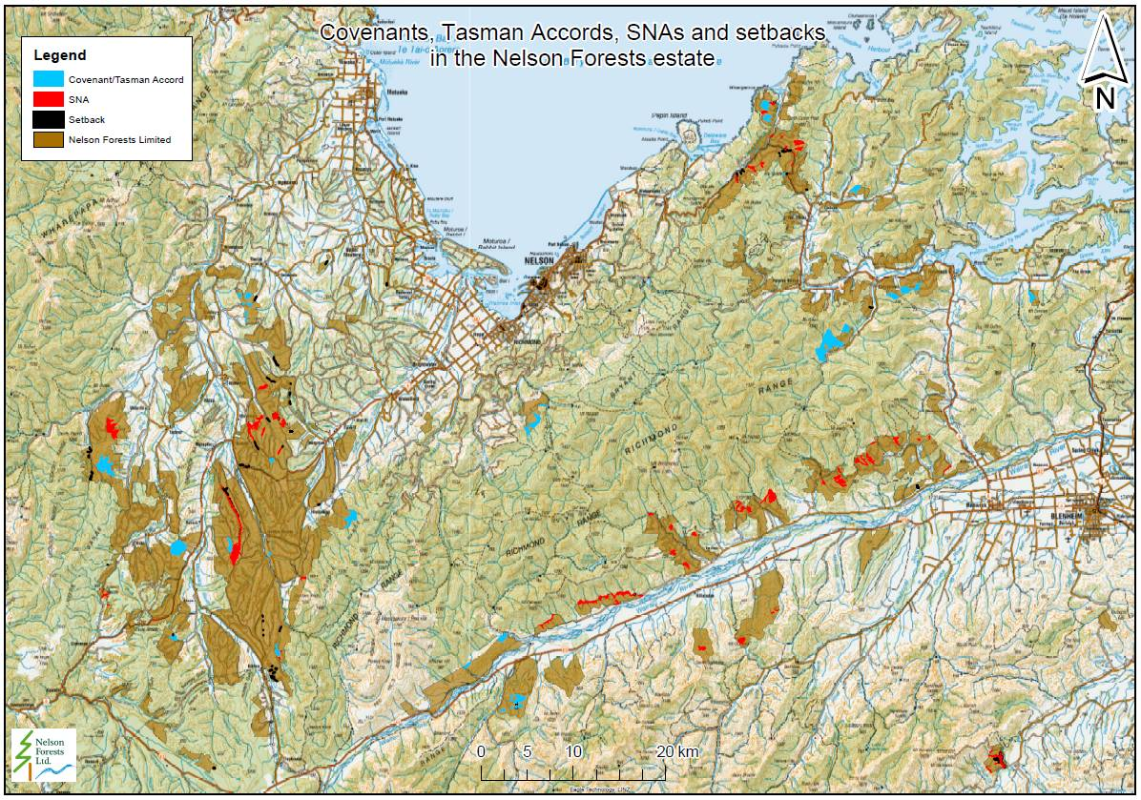
Distribution of Set-asides in the OneFortyOne Estate

11. Socio-Economic Conditions

OFO has a sponsorship committee that manages a sponsorship fund. The committee receives applications from community groups and individuals and allocates sponsorship where it sees alignment to the company’s values.

Operations carried out in the estate are undertaken with due consideration to the occupiers of neighbouring land. Planning for operations includes prior consultation with neighbours likely to be affected.

Recreational use is allowed for and encouraged on a permit basis during periods of low fire risk. Hunting is the most popular recreational pastime in the forest with close to 300 hunting permits issued annually. The number of pigs and deer caught in a year in the forest is estimated at 500 -700. Other recreational uses of the forest include mountain biking, horse riding, picnicking, access for fishing & tramping, car rallying events, motor cross events and off-road rallying events.

OFO is also undertaking targeted community engagement in areas where high intensity rain events may trigger landslides and/or where rural fires may threaten rural communities. Progress on this work is reported in the annual Monitoring Report.

12. Environmental Monitoring

Regular internal and external environmental audits are carried out to ensure that operations are being carried out to the required standards.
Following harvesting operations, a post-operation environmental check is completed across all sites to ensure that the remedial works and water controls have been put in place.
An incident / observations record database exists to record any observations or environmental incidents that have occurred because of a climatic event, a breach of EMS standard or a significant adverse effect.

13. Threatened Species

Threatened species are identified and monitored through natural area surveys and through reports from staff, contractors and forest-users. A Threatened Species guide has been provided to all operational staff and crews working in the forest. Everyone is encouraged to report sightings.
Forest operations adhere to standards developed in the OFO Environmental Management System (EMS) that have been developed to protect biodiversity values from adverse effects of forest operations or activities.

14. Further Reading
A full social, economic and environmental monitoring report based on the Montreal Process is prepared annually and it available on the OneFortyOne New Zealand website.
https://onefortyone.com/environmental-and-social-monitoring-report-2019-new-zealand/

Environment includes the atmosphere, waterways, soil, landscape, ecosystems, people and communities
Significant (environmental) effect includes adverse or beneficial effects. It can be temporary or permanent, past, present or future & any cumulative effects that arise over time or in conjunction with other effects that have been evaluated as having the potential to cause a significant impact on the environment. The main environmental effects relate to: Changes to soil structure and fertility, soil erosion, water quality & yield, air quality, landscape, neighbour relations, biological diversity, pollution of land or water from fuel/chemicals/contaminants, carbon sequestration, & cultural values/recreation/aesthetics.

